1. (P2) Only filenames that begin with an upper-case letter **[[:upper:]]\***
2. (P13) Attach a system to a Red Hat account **register**
3. (P2) This directory contains dynamic configuration data such as FTP and website **/var**
4. (P 1) Re-execute a recent command by matching the command name **string**
5. (P5) Anumber that identifies the user at the most fundamental level **UID**
6. (P5) The program that provides the user's command line prompt **login shell**
7. P4) Send command output to both the screen and a file at the same time **| tree file**
8. (P14) The device file of a SATA hard drive residing in /dev **/dev/sdc**
9. P2) Regular user commands and utilities are located here **/usr/bin**
10. P2) Move to the binaries location from any current location **cd/bin**
11. The fourth field of /etc/passwd **primary group**
12. (P4) Send output and errors to the same new, empty file **&>file**
13. P1) Re-execute a specific command in the history list **!number**
14. (PS) A number that identifies the group at the most fundamental level **GID**
15. (P2) Only filenames where first character is not "b**\* [!b]\***
16. An interface that provides a display for output and a keyboard for input to a shell session **terminal**
17. A collection of RPM packages and package groups **repository**
18. (P11) The following picture means **this configuration is feasible**
19. [P2) List the current location (long format) with hidden files **ls-al**
20. (P2) Determine the absolute path name of the current location **pwd**
21. P1) The part of the command line that adjusts the behavior of a command **option**
22. 1P4) Shortcut used to complete commands, file names, and Options **tab**
23. (P2) Only filenames that contain a number **\*[[:digit:]]\***
24. P1) Copy the last argument of previous commands **esc+**
25. (PS) Location of local group information **/etc/group**
26. (P6 pic) Can be deleted by the user barney **none**
27. (P6 pic) Contents may be modified by the user betty **|file 2**
28. (P2) Return to the most previous working directory **cd..**
29. (P11) The following picture means **invalid IPv4 address**
30. (P13) The processor type required for a specific package **Arhitecture**
31. (P10) The log file for security and authentication related messages and errors **/var/log/secure**
32. (P14) The device file of a logical volume in /dev **/dev/vg_install/v_home**
33. (P10) Most syslog messages are logged here. The exceptions are messages related to authentication, email processing. and that periodically run jobs, or those which are purely debugging related **/var/log/massages**
34. (P6 pic) Can be deleted by the user fred **all**
35. (P10) The log file related to periodically executed tasks **/var/log/cron**
36. This directory contains dynamic configuration data such as FTP and websites
37. /usr
38. /etc
39. /var
40. /root
41. Send command output to file; errors to different file
42. >file 2>file2
43. 2>/dev/null
44. file 2> /dev/null
45. &>file
46. Process is running or waiting to run on a CPU
47. R
48. S
49. D
50. T
51. The fourth field of /etc/passwd
52. primary group
53. home directory
54. login shell
55. UID
56. List the current user's home directory (long format) in simplest syntax. when it is not the current location
57. ls -l ~
58. cd
59. pwd
60. ls -al
61. The following picture means
62. name resolution is not configured
63. gateway is not on the same subnet
64. IP address cannot be a network address
65. this configuration is feasible

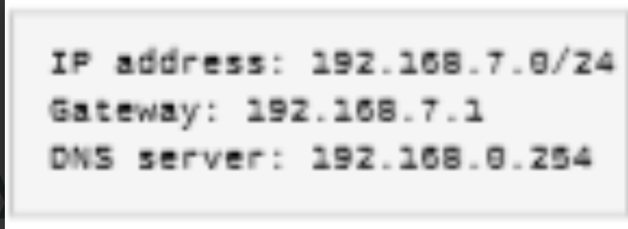

1. The part of the command line that specifies the target that the command should operate on
2. Virtual console
3. Terminal
4. Option
5. Argument
6. Jump to the beginning of the previous word on the command line
7. Ctrl+k
8. !string
9. Ctrl+Left Arrow
10. Ctrl+Right Arrow
11. Can be deleted by the user barney
12. rfile1
13. rfile2
14. all
15. none

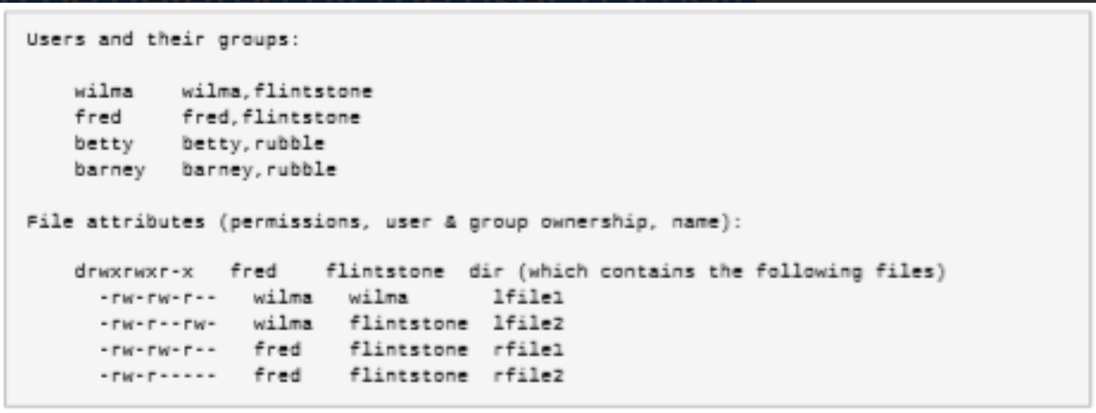

1. System administration binaries for root use are here
2. /usr/bin
3. /usr/sbin
4. /etc
5. /usr
6. Only filenames that contain a number
7. *[[:digit:]]*
8. [[:digit:]]
9. *[[digit]]*
10. [[*digit*]]
11. The visual cue that indicates an interactive shell is waiting for the user to type a command
12. Shell
13. Prompt
14. Command
15. Option
16. Has a group ownership of wilma
17. rfile1
18. rfile2
19. lfile1
20. lfile2

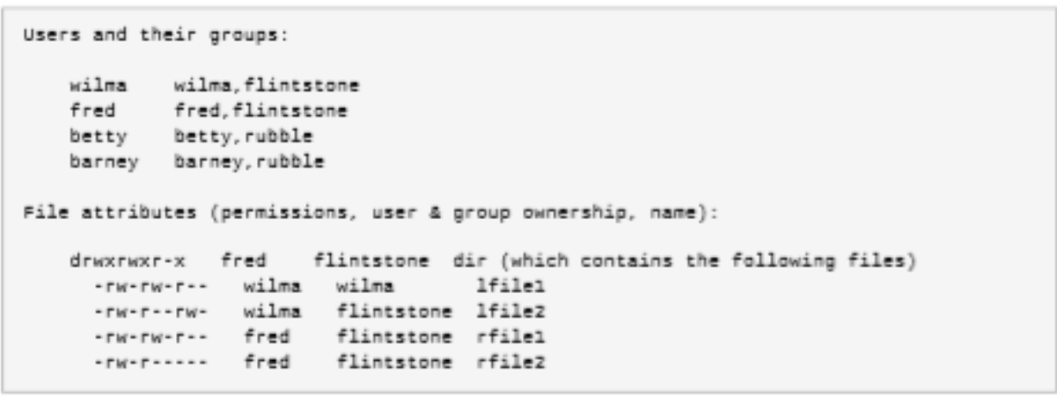

1. Separate commands on the same line
2. ;
3. "
4. :
5. –
6. Only filenames containing a "b"
7. [!b]*
8. *b*
9. b*
10. "b"
11. Re-execute a recent command by matching the command name
12. !string
13. !number
14. Tab
15. Ctrl+z
16. The part of the command line that adjusts the behavior of a command
17. Option
18. Argument
19. Physical console
20. Command
21. List of reasons for each package build
22. Changelog
23. Release
24. Version
25. Repository
26. Regular user commands and utilities are located here
27. /usr/bin
28. /usr/sbin
29. /etc
30. /usr
31. Contains dynamic. non-persistent application runtime data
32. /tmp
33. /var
34. /run
35. /root
36. Send command output to both the screen and a file at the same time
37. | tee file
38. 2>/dev/null
39. >>file 2>&1
40. &>file
41. The following picture means
42. IP address cannot be a network address
43. this configuration is feasible
44. gateway is not on the same subnet
45. invalid IPv4 address

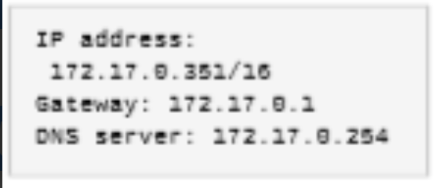

1. Move up two levels from the current location
2. cd ../..
3. cd bin
4. cd -
5. cd
6. Used to verify the source and integrity of a package
7. GPG signature
8. Repository
9. Changelog
10. Architecture
11. Only filenames beginning with "b"
12. *b
13. *b*
14. b*
15. /b
16. The device file of the third partition on the second SATA hard drive in /dev
17. /dev/sdb
18. /dev/sdc
19. /dev/sdb3
20. /dev/sda2
21. Process is waiting for I/O or some condition to be met and must not respond to signals
22. Z
23. D
24. T
25. R
26. Display the list of previous commands
27. history
28. previous
29. Esc+Left Arrow
30. Esc+Up Arrow
31. User home directories are located under this directory
32. /home
33. /etc
34. /tmp
35. /usr/bin
36. Contains installed software programs and libraries
37. /usr
38. /usr/bin
39. /usr/sbin
40. /run

1. (P13) Used to verify the source and integrity of a package

**GPG signature**

2. (P1) Jump to the beginning of the previous word on the command line

**Ctrl+Left Arrow**

3. (P1) Separate commands on the same line

**;**

4. (P7) Process has released all its resources except its PID

**Z**

5. (P1) Clear from the cursor to the end of the command line

**Ctrl+k**

6. (P14) The device file of a SATA hard drive residing in /dev

**/dev/sdc**

7. (P2) This is the system's root directory

**/**

8. (P1) Display the list of previous commands

**history**

9. (P2) This directory contains static. persistent system configuration data

**/etc**

10. (P13) Enable a system to use selected Red Hat products

**subscribe**

11. (P11) The following picture means

**invalid IPv4 address**

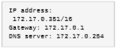

12. (P4) Run command. save output in a file. discard error messages

**> file 2> /dev/null**

13. (P1) The hardware display and keyboard used to interact with a system

**Physical console**

14. (P2) Temporary files are stored here

**/tmp**

15. (P2) Only filenames containing a "b"

**\*b\***

16. (P4) Send output and errors to the same new. empty file

**&>file**

17. (P7) Process is waiting for I/O or some condition to be met and must not respond to signals

**D**

18. (P2) Move up two levels from the current location

**cd ../..**

19. (P11) The following picture means

**name resolution is not configured**



20. (P2) Return to the current user's home directory

**cd**

21. (P1) Re-execute a specific command in the history list

**!number**

22. (P13) Determine the number of available subscriptions

**review and track**

23. (P4) Send output and errors to the same file but preserve existing file content

**>>file 2>&1**

24. (P5) Location of local group information

**/etc/group**

25. (P1) The part of the command line that adjusts the behavior of a command

**Option**

26. (P10) The log file with mail server-related messages

**/var/log/maillog**

27. (P6 pic) Can be deleted by the user barney

**None**

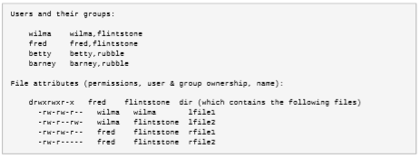

28. (P14) The device file of the third partition on the second disk in a virtual machine in /dev

**/dev/vdb3**

29. (P2) Move to the binaries location from the root directory

**cd bin**

30. (P2) Only filenames beginning with "b"

**b\***